Document Based Question (Unit 3)
The following question is meant to illustrate the type of question that might appear in section IV of the exam.* Each question focuses on a particular historical thinking skill (in this case, patterns of continuity and change over time). The question is based on the accompanying documents.
*This DBQ was adapted from the 2004 AP Examination

Responses should do the following:
- State a relevant thesis that directly addresses all parts of the question.
- Support the thesis or a relevant argument with evidence from all, or all but one, of the documents.
- Incorporate analysis of all, or all but one, of the documents into the argument.
- Focus the analysis of each document on at least one of the following: intended audience, purpose,
historical context, and/or point of view.
- Support the argument with analysis of historical examples outside the documents.
- Connect historical phenomena relevant to the argument to broader events or processes.
- Synthesize the elements above into a persuasive essay that extends the argument, connects it to a
different historical context, or accounts for contradictory evidence on the topic.

PROMPT:
Evaluate the extent of change and continuity in the relationship between Great Britain & its American colonies during the period 1740 – 1766.
Document 1
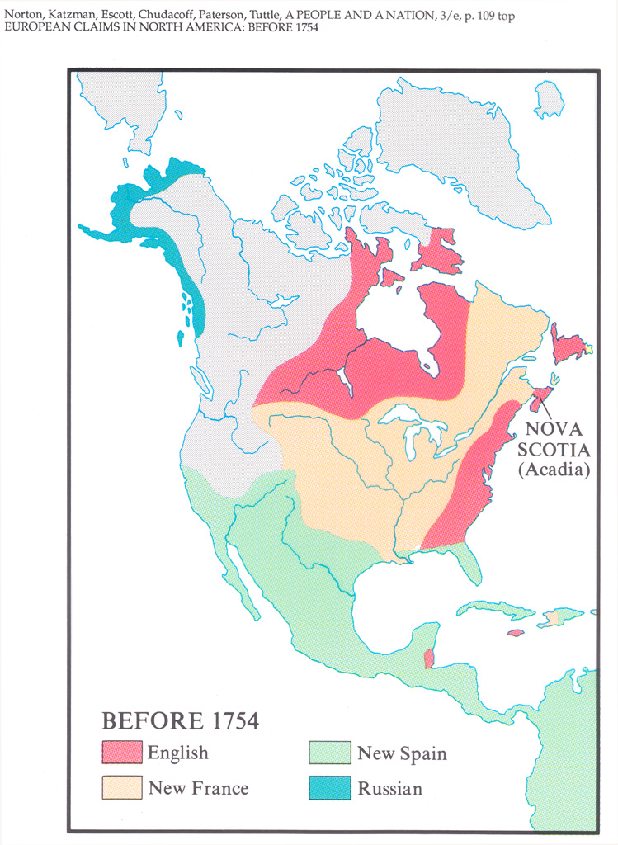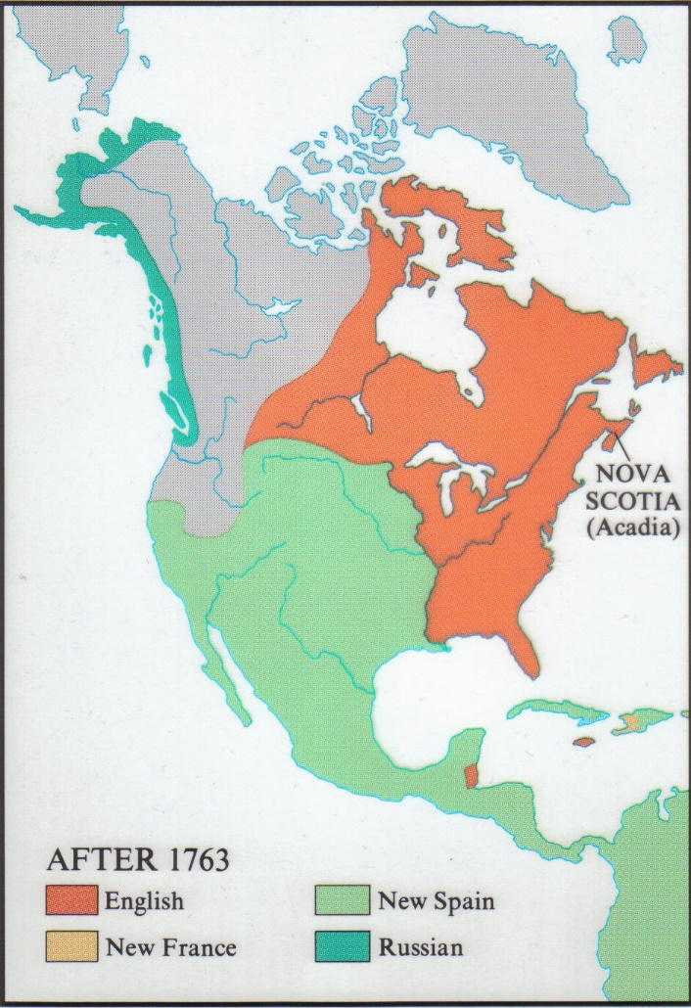

Document 2
Source: Canassatego, Chief Onondaga Nation of the Iroquois Confederacy, speech to representatives of Pennsylvania, Maryland and Virginia, 1742
We know our Lands now become more valuable. The white People think we do not know their Value; but we are sensible that the land is everlasting, and the few goods we receive for it are soon worn out and gone… We are not well used with respect to land that are still unsold by us. Your people daily settle on these lands and spoil our hunting. We must insist of your Removing them, as you know they have no Right to settle.

Document 3
Surce: George Washington, letter to Robert Orme, aide-de-camp to General Edward Braddock, March 15, 1755
It is true, sir, I have, expressed an inclination to serve in this campaign as a volunteer; and this inclination is not a little increased, since it is likely to be conducted by a gentleman of the general's experience.
But, besides this, and the laudable desire I may have to serve with my best abilities my king and country, I must be ingenuous enough to confess, that I am not a little biased by selfish considerations. To explain, sir, I wish earnestly to attain some knowledge in the military profession, and, believing a more favorable opportunity cannot offer than to serve under a gentleman of General Braddock's abilities and experience

Document 4
Source: British Order in Council, 1763
We, the Commissioners of your Majesty’s Treaty beg leave humbly to represent to your Majesty that having taken into consideration the present state of the duties of customs imposed on your Majesty’s subjects in America and the West indies, we find that the revenue arising therefrom is very small and inconsiderable… and is not yet sufficient to defray a fourth part of the expense necessary for collecting it. We observe with concern that through neglect, connivance and fraud, not only is revenue impaired, but the commerce of the colonies diverted from its natural course…[This revenue] is more indispensable when the military establishment necessary for maintaining these colonies requires a large revenue to support it, and when their vast increase in territory and population and population makes the proper regulation of their trade of immediate necessity.

Document 5
Source: Rev. Thomas Barnard, sermon, Massachusetts, 1763
Auspicious Day! When Britain, the special Care of Heaven, blessed with a patriot-Sovereign served wise and faithful Councilors, brave Commanders, successful Fleets and Armies, seconded in her efforts by all her children, and by none more zealously than those of New England…
America, mayest well rejoice, the Children of New England may be glad and triumph, in Reflection on Events past, and Prospect for the future…
Now commences the Era of out quiet Enjoyment of those liberties which our Fathers purchased with the toil of their whole lives, their treasure, their blood. Safe from the enemy of the wilderness, safe from the gripping hand of arbitrary sway and cruel superstition, here shall be the late founded Seat of Peace and Freedom. Here shall our indulgent Mother, who has most generously rescued and protected us, be served and honored by growing Numbers, with all Duty, Love and Gratitude, till Time shall be no more.

Document 6
Source: Benjamin Franklin (in London) letter to John Hughes (in Pennsylvania), August 9, 1765
As to the Stamp Act, though we propose doing our Endeavor to get it repealed in which I am sure you would concur with us, yet the success is uncertain. If it continues, your undertaking to execute it may make you unpopular for a time, but your coolness and steadiness, and with every circumstance in your power of favor to the people, will by degrees reconcile them. In the meantime, a firm loyalty to the crown and faithful adherence to the government of this nation, which it is the safety as well as the honor of the colonies to be connected with, will always be the wisest course for and I to take.

Document 7
Source: Newspaper masthead, October 1765
